Response to Reviewers

Reviewer #1

The data provided in the manuscript that 2B4 is expressed on CD4+ T cells from sepsis subjects are not convincing, and the data do not support solidly that inhibition of ES is solely mediated by 2B4 expressed on CD4+ T cells (see detailed comments below).

Fig. 1: (1). Other mabs should be applied by FACS to confirm that 2B4 is expressed on ES CD4+ T cells. The authors did not mention what 2B4 mab was used, and expression of 2B4 on CD8+ T cells is strange;

In order to address this concern, we have performed new experiments and tested multiple anti-2B4 clones demonstrating the upregulation of 2B4 during sepsis. WT or 2B4-/- animals were subjected to CLP and sacrificed at 24 hours post-CLP, the time point we observed highest 2B4 expression in kinetic results. The clone we used in our first submission was eBio244F4 from eBioscience, sincerely apologized for didn’t mention in first submission. Splenocytes were havested and stained for 2B4 with two new different clones: 1. Clone: m2B4 (B6)458.1 from Biolegend and 2. Clone: 2B4 from BD bioscience (see figure below demonstrating the expression of 2B4). Consistent to our original data, 2B4 expression was significantly upregulated on both CD4 and CD8 T cells after 24 hours post sepsis. And in these experiments, 2B4-/- animals were served as a negative control.

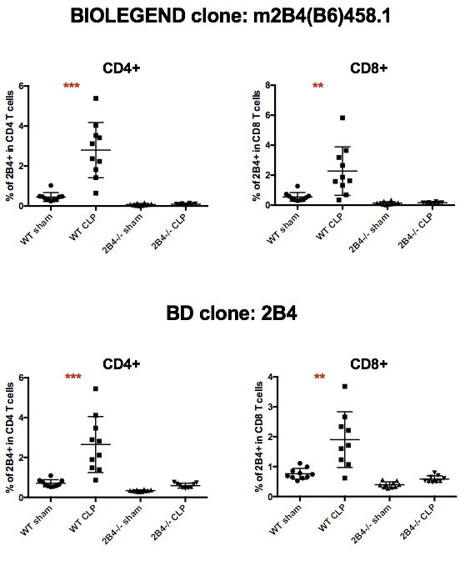

(2). As a negative control for these stainings, CD4+ T cells from 2B4 KO mice should be used;

Response: We now include 2B4-/- NK cells and T cells as a negative control in Figure 1A. As the data shown, 2B4-/- animals did not have 2B4 staining on lymphocytes population.

(3). expression of other SLAM family receptors should be checked;

We agree with the reviewer that this is an interesting area of investigation; therefore, we conducted new experiments and determined different SLAM family receptor expressions during sepsis. WT animals were subjected to CLP and sacrificed at 24 hours post-CLP, and all SLAM family receptors were assessed. Besides of 2B4 (SLAMf4), we investigated the expression of SLAMf1 (CD150), SLAMf2 (CD48, the ligand of 2B4), SLAMf3 (Ly9), SLAMf5 (CD84) and SLAMf6 (Ly108) during sepsis. Please refer to the data in below figures. For space restrictions, we have only included SLAMf2 results in our manuscript (Figure 1E); however, if reviewer considers other SLAM family results are necessary, we will be delighted to include in our manuscript. After 24 hours post CLP, we found no difference on SLAMf1 and SLAMf6 between CLP group and sham group. However, SLAMf3 expression on CD4+ T cells was decreased during CLP but expression on CD8+ T cells ware similar. Although the mean fluorescence intensity (MFI) of SLAMf2 (CD48) exhibited significant decreases on both CD4+ and CD8+ T cells, SLAMf2 remained highly expressed on ALL T cells, B cells and NK cells (Figure 1E, data not shown), suggesting that 2B4 upregulation might be the major contributor for increasing 2B4-signaling on T cells. For SLAMf5 (CD84), we could not detect the expression on CD3+ populations (data non shown). Combined together, 2B4 (SLAMf4) is the only SLAM receptor was upregulated on T cell surfaces, which might emphasize the importance of 2B4 in T cell cosignaling control during sepsis.

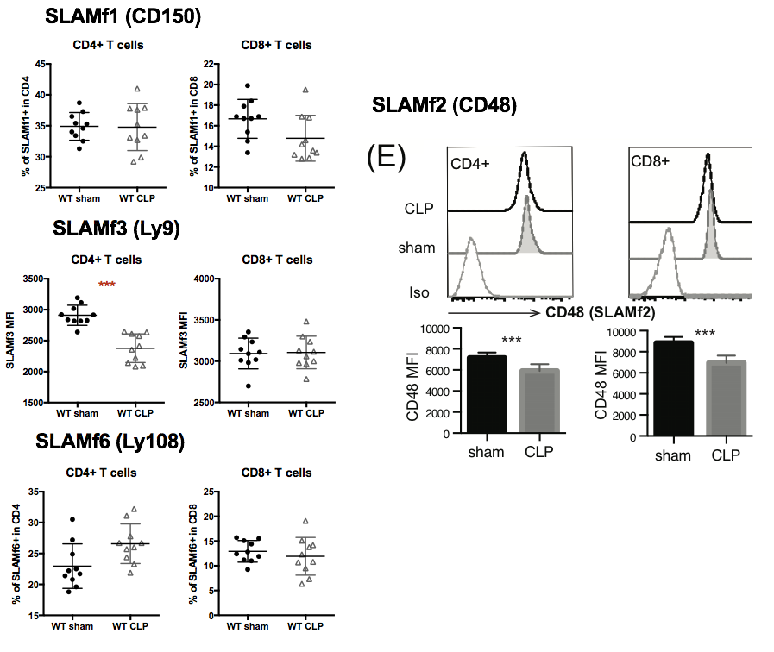

(4). Splenocytes, both live and dead, should be counted, as apoptosis of immune cells might be associated with ES.

Fig. 2: (5). Splenocytes, both live and dead, should be counted.

We agree with the reviewer that apoptosis of immune cells is a critical factor during sepsis. To address this question, we performed Caspase3/7 activity by flow cytometry (ThermoFisher) on T cells during sepsis. Aged and gender matched WT and 2B4-/- animals were subjected to CLP and sacrificed at 24 hours. In this experiment, apoptotic cells were identified as Caspase3/7+SYTOX-. After sepsis, we found that 2B4-/- animals showed decreased percentage of apoptotic CD4+ T cells compared to WT animals. However, absolutely cell counts revealed that apoptotic cells number has no different between WT and 2B4-/- animals, but the “live” cell numbers are significantly higher in 2B4-/- animals, indicating that CD4+ T cells in 2B4-/- animals is much resistant to sepsis induced cell apoptosis.

We have included apoptotic results in Figure 2C, and the apoptotic/intact cell counts were placed in supplemental figures.

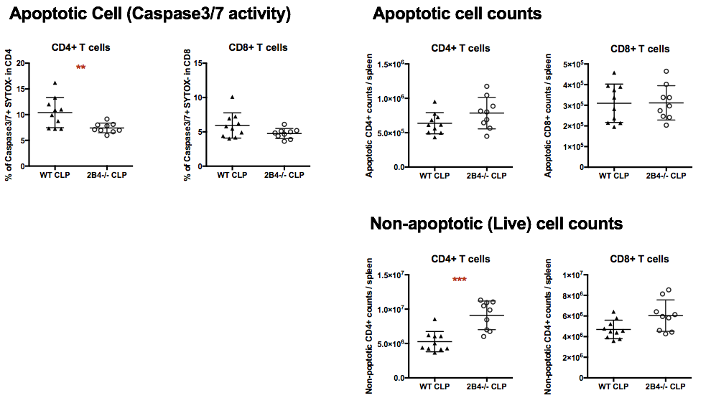

Fig. 3, 4A: (6). Splenocytes, both live and dead, should be counted;

We believe this is an interesting direction, however, we think this might be outside the scope of manuscript. We will be delighted to test this hypothesis in our future experiments.

(7). Composition of different immune cells (CD4+, CD8+, B, NK, and NK-T), should be analyzed by FACS. Their expression of 2B4 should also be monitored;

To address reviewer concern, prior to CLP, blood sample from control chimera and CD42B4-/- chimera mice were harvested and assessed for B cells and T cells compositions. Following Emory IACUC restrictions, only 20μL of blood could be sampled from each animal. We only could assess the compositions of B cells and T cells in peripheral blood. No difference was found between control chimera and CD42B4-/- chimera animals. To further confirme the chimera phenotype, we also follow reviewer suggestion to examine 2B4 expression on T cells population before and after CLP. We have included the representative flow figures showing that in CD42B4-/- chimera, CD4+ T cells expressed lower level of 2B4 compared to WT animals prior to CLP. Importantly, contrast to control chimera, CD4+ T cells in CD42B4-/- chimera did not increase 2B4 expression after CLP.

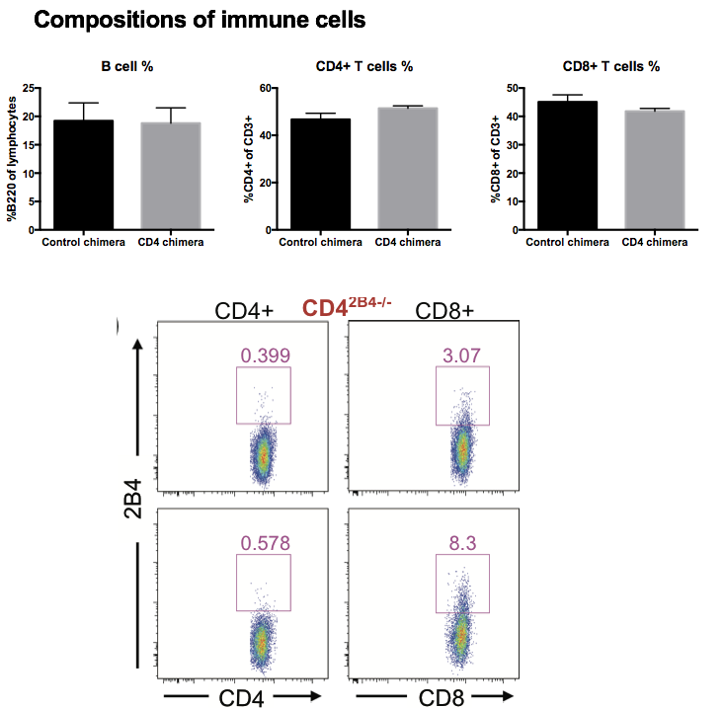

Fig. 4B-C: (8). Sample plot should be provided.

**Response:** We now include a representative flow panel in figure 4A depicting the raw data, which are summarized in the graphs.



Reviewer #2:

The well written and interesting manuscript by Chen et al explores the role of CD244 (2B4) signaling in sepsis-induced lymphocyte dysfunction and survival. Elegant experiments using gene KO, BM chimeras or pharmacological 2B4 blockade suggested potential role of 2B4 in increased mortality after sepsis.

However, the idea that CD4 T cells in 2B4 deficient hosts exhibit more effector memory phenotype and have higher functionality leading to better survival after sepsis, although intriguing, is not fully supported by the data presented.

For example, is the lymphocytes status (%, naïve vs memory composition, baseline expression of relevant markers... etc) of WT and 2B4 KO mice identical in age/sex matched mice before sepsis induction. If not, sepsis-induced changes (Figure 2) are hard to interpret.

Response:

We completely agree reviewer comments and we conducted a new experiment, which separated aged match and gender match WT and 2B4-/- animals into four groups: WT sham, WT CLP, 2B4-/- sham and 2B4-/-CLP. After 24 hours post CLP, animals were sacrificed and absolutely CD4+ T cell and CD8+ T cell numbers were determined. In the four group comparison, no statistic difference was found between WT sham and 2B4-/- sham on both CD4 and CD8 T cells. However, we found significant higher CD4 numbers in 2B4-/- CLP group compared to WT CLP (Figure 2B). Combining with apoptotic data (Figure 2C), CD4+ T cells in 2B4-/- animals were resistant to sepsis-induced cell apoptosis and also maintained higher IFN-γ secretion ability during sepsis.



Few additional comments for authors to consider:

*• What is the relevance of KLRG-1 expression on CD4 T cells?*

**Response:**

KLRG-1 expressed on CD4 T cells has been showed correlated to a short lifespan and effector cytokine secretion cells in a tuberculosis infection model. We believe KLRG-1 could be a terminal differentiation or effector markers for CD4 in our sepsis model.

[Proc Natl Acad Sci U S A](https://www.ncbi.nlm.nih.gov/pmc/articles/PMC2984157/). 2010 Nov 9; 107(45): 19408–19413

*• Does blocking 2B4 signaling and increase in IFNg production by T cells contribute to increased sepsis-induced cytokine-storm early after sepsis induction? How this is beneficial and not detrimental to the host?*

**Response:**

To address the reviewer concern, we measured the serum cytokine TNF and IL-1β post CLP, which are critical cytokines correlated with sepsis-induced cytokine-storm. Four groups of animal serum plasma were collected after 24 hours subjected to CLP, including WT, 2B4-/-, control chimera and CD42B4-/- chimera (see the figure below). Our data showed that there is no difference was found between WT and 2B4-/- or between the chimera groups, indicating that blocking 2B4 pathway and increased IFN-γ production might not result in sepsis-induced cytokine-storm.

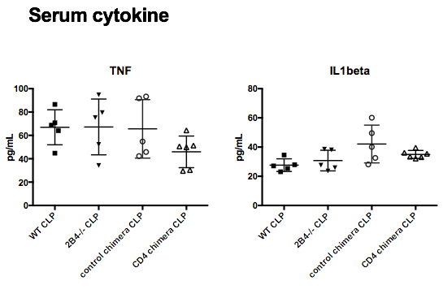

• *In reality, most of the T cells in vivo are not of naïve phenotype. How 2B4 blockade affects T cells that are not naïve and have capacity to respond to sepsis-induced inflammatory cues? At least the authors should discuss this issue.*

**Response:**

We completely agree with the reviewer concern about the different response between naive T cells and memory T cell during sepsis. In human, the majority of T cells are memory cells; however, in an inbred housing experimental mouse, around 80% of the T cells will be naive cells. We previously published that memory T cells are more susceptible to sepsis induce dysfunction. Interestingly, we found most of 2B4 expression was on CD44hi population after sepsis induction. We have added one new figure at Figure 1D, indicating that 2B4 was function as a cosignaling receptor mostly on memory cell populations. Therefore it is possible that blockade of 2B4 might rescue the dysfunction of memory population and lead to increased survival.

In future direction, to further dissect the function of 2B4 on memory T cell population, we have established one “memory mice” model, which animals will be infected with virus and bacteria to induce memory T cell populations. In this model, we will further conduct how blockade of 2B4 influence memory T cells response during sepsis.

• *It is not clear how upregulation of CD86 on macrophages observed in CD42B4-/- mice in spite of comparable levels of bacteria contributes to better survival? This attempt to mechanistically explain the observed phenomena is not sufficiently developed/explained.*

Response:

Several studies have already shown that bacteria broaden is not necessary correlated with survival in CLP model,

It is well known that macrophages can differentiate into two phenotypes: pro-inflammatory (M1) or anti-inflammatory (M2) depends on different pathogen or cytokine stimulations. M1 macrophage phenotypes include higher MHCII and CD86 expression, which provide more costimulatory signaling to adaptive immune system. During sepsis, evaluated M2 macrophages and decreased M1 macrophages have been observed in several animal models and also in septic patients.

Macrophages have been shown play several important roles during sepsis, including polarizing adaptive immune system. Here we found that increased CD86 expression was found on macrophages in CD42B4-/- chimera, which indicating more activated macrophages were observed in those animals. Although we did not find an improvement of bacteria clearance, those activated macrophages might still impact sepsis pathogenicity through enhancing wound healing. Macrophages are an absolute necessary factor in the inflammatory phase of healing (usually from injury to 4 days). During this phase, macrophages subsequently replace the neutrophil infiltration to the wound and produce growth factors to promote fibroblast growth. In sepsis, wound-healing process is usually impaired due to hypoxia and infections. Although we did not follow up to late stage of CLP and assess macrophages function, more activated macrophages were found at 24 hours post CLP might lead to improved wound healing, which is one possible mechanism for increased survival.

Moreover, CD86

or polarizing more Th1 cells in adaptive immune system.